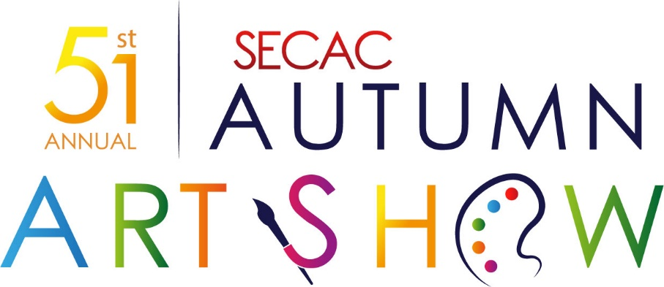

Sponsored in part by the Southeast Colorado Arts Council/Anne Boken Trust, Prowers Partners for Progress, Arkansas Valley Wind & Percussion Ensemble, Inc.

October 29-November 1, 2020

Call for Artists
Shore Arts Center invites submissions for the 51st annual SECAC Autumn Art Show. Accepted entries will be on display from October 29th thru November 1st. An opening reception will be held from 6-9 pm on October 29, 2020. The reception is free and open to the public. Wine, beer and cheese will be served and the People’s Choice voting will be held from 6-7:30pm. The awards presentation will begin at 8pm. All artists are invited and encouraged to enter and attend. There will be divisions for adults and students. The following awards will receive cash prizes in each age division: Best of Show, People’s Choice, Area Attractions, and the Southeast Colorado Arts Council/Anne Boken Trust Award. Our featured guest artist and judge will be Nancy West Bennett.

Online Pre-Registration opens February 1st 2020. ALL Artwork, Entry Fees, and Late Registrations will be accepted on October 24th from 2-5pm and on Sunday October 25^{h} from 2-5pm at the Shore Arts Center, 115 Main Street, Lamar, CO.

Cash Prizes and Ribbons
Adult Division: Best of Show $400, People’s Choice $200, Area Attraction $200, and Southeast Colorado Arts Council/Anne Boken Trust Award $200
High School - SR Division: Best of Show $50, People’s Choice $25, Area Attraction $25, and Southeast Colorado Arts Council/Anne Boken Trust Award $25
Elementary - JR Division: Best of Show $25, People’s Choice $15, Area Attraction $15, and Southeast Colorado Arts Council/Anne Boken Trust Award $15
First, Second, Third, and Honorable Mention certificates will be awarded in each category also.

Media Accepted: Watercolor, Acrylic, Oil, Graphite, Ink, Mixed Media, Photography, Colored Pencil, Digital/Graphic Art, Sculpture, Collage, Fiber Arts, and Artisan Crafts.

Size: Artwork cannot be larger than 4ft wide and 8ft tall unless special arrangements are made.

Style: All artistic styles are welcome.

Subject Matter: All subject matter welcome.

Delivery: Costs of shipping artwork and/or delivering artwork to and from Shore Arts Center is the sole responsibility of the artist. If the artwork does not sell, it is the responsibility of the artist to pick up the artwork by 5pm on Sunday, November 1st, 2020. Any artwork that is left after this date and time will become the property of AVWPE, Inc. and used to fund future shows. No exceptions as this has been a problem in previous shows.

Display: All artwork MUST be wired and/or properly prepared for hanging. Works that do not fit this criteria will not be accepted.

Insurance: The Shore Arts Center does NOT provide insurance for artwork. If the artist would like to insure their artwork during transit and exhibition, they must do so themselves.

Pricing: All artwork must be available for sale with prices clearly labeled on the registration form(s) OR clearly marked NFS (Not For Sale). Artists will be informed immediately when sales are made either by phone or email. The Shore Arts Center takes a 25% commission on sales, which the artist must factor into their pricing at time of registration. By participating in this exhibition, the artist agrees to allow the Shore Arts Center to negotiate up to 10% from their submitted price to facilitate sales.

Submitting Information: Artists cannot change details or information on their registration submissions after the deadline for entries has passed. Exhibition labels, show lists, and online information are generated from the information provided at the time of registration. Please verify your submission information and ensure that it is correct BEFORE turning it in.

HOW TO ENTER: This show is open to all artists and includes an Elementary JR division for children ages 5-12, a Middle/High School SR division for students ages 13-18, and an Adult division for anyone 19 and older. We encourage all artists to pre-register online by filling out the submission form found at www.avwpe.org/autumn-art-show and then the registered artwork must be delivered to Shore Arts Center at the registration times found above. Payment must accompany the artwork and is due prior to work being accepted. If you have any questions or need assistance, please contact Trevor La Cost trevor.lacost@avwpe.org or Chris Duffy chris.duffy37@gmail.com for questions or more information.

Entry Fees: The entry fee is $35/adult artist and is non-refundable. Artists can submit up to 10 entries. Children/Student entries are free and are limited to 3 entries per person.

Conditions: Submission of entry to this exhibition automatically constitutes the entrant’s acceptance of the guidelines and rules outlined in this Call for Artists. Due to the volume of entries, Shore Arts Center nor our judge will provide individual feedback on submissions. The judge’s decisions are final. *Information within this prospectus, including prizes, is subject to change and is at the discretion of the Shore Arts Center.

Autumn Art Show Schedule
February 1st, 2020 Online Pre-Registration Open

October 24th, 2020 Registration and Delivery of Artwork 2-5pm
October 25th, 2020 Registration and Delivery of Artwork 2-5pm

October 29th, 2020 10am - Judging
October 29th, 2020 Opening Reception 6-9pm
People’s Choice Voting ends at 7:30pm
Awards Presentation 8pm

October 30th, 2020 Show Open from 1pm to 6pm

October 31st, 2020 Show Open from 1pm to 6pm

November 1st, 2020 Show closing - ALL Artwork must be picked between 2-5pm

Sponsors
Southeast Colorado Arts Council/Anne Boken Trust
Prowers Partners For Progress
Southeast Health Group
Arkansas Valley Diesel Service, Inc.
AVWPE, Inc.

